**Vintage Hand Hammered Round Copper Wall Mirror**

**Price: $385**

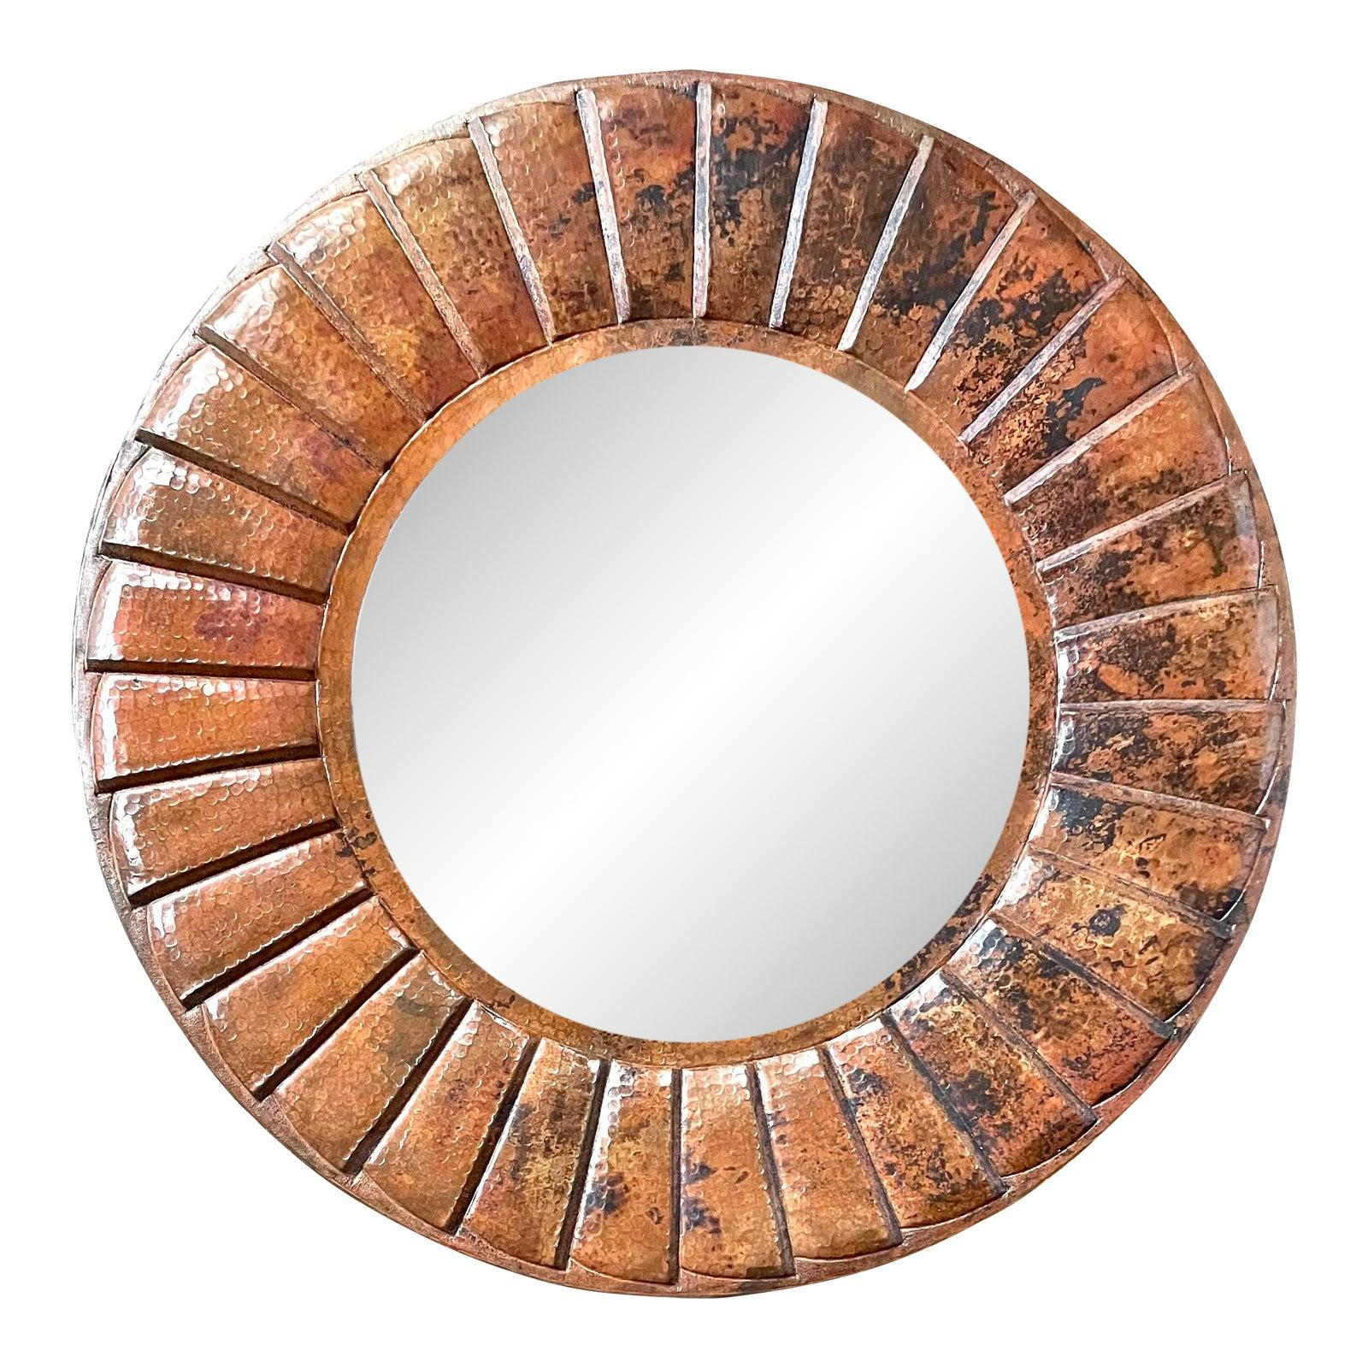

* CATEGORIES

Dressing Room

* MATERIALS

Decorative Mirrors

* SHAPE

Circle

* BRAND

Inax